Safety Message
Fleet/Safety Manager
BLIND SPOTS
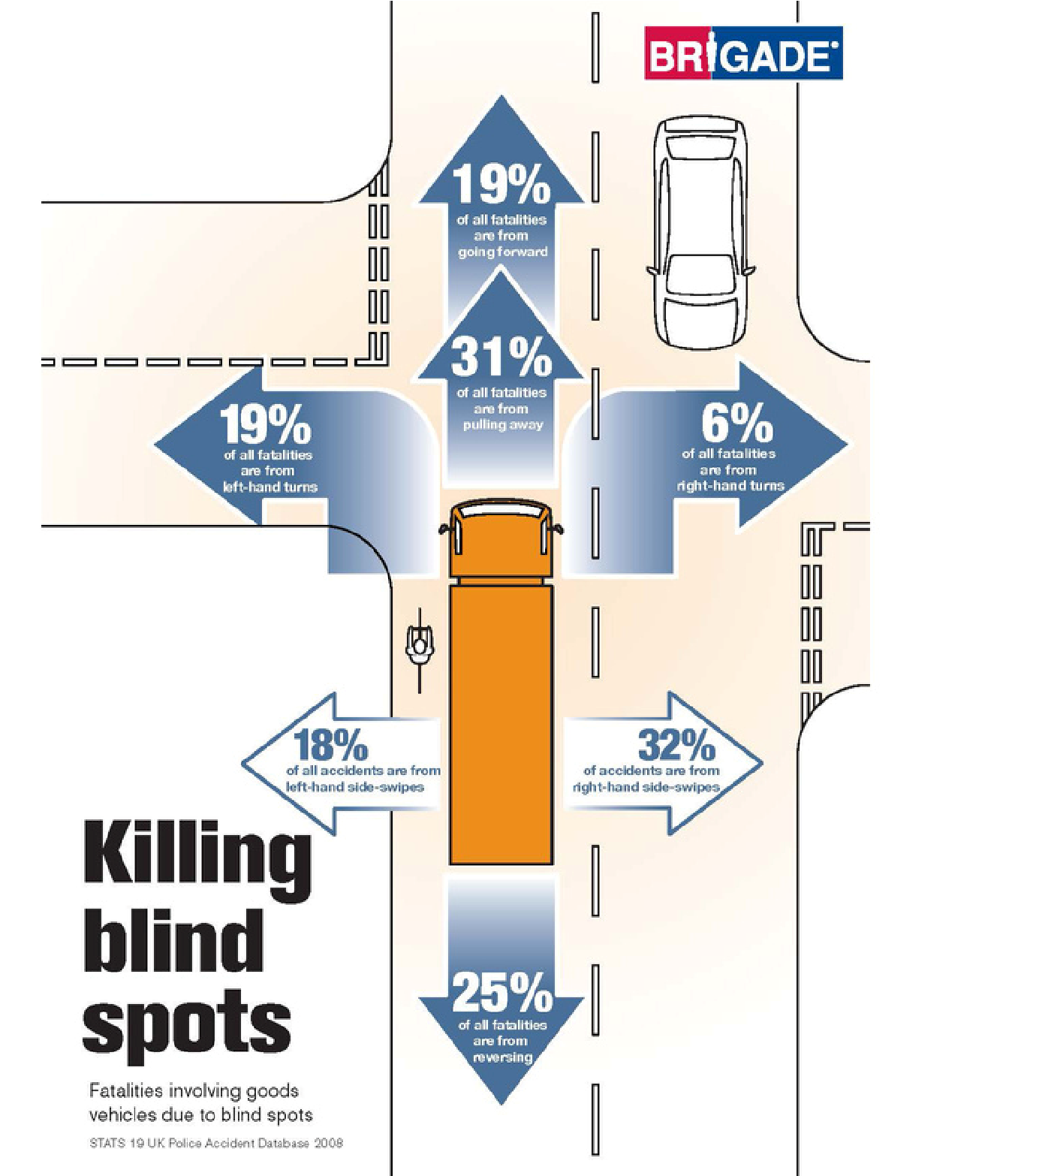
Part of being a defensive driver includes being mindful of blind spots, both yours and those of other drivers.
Learn how to adjust your mirrors and driving style to avoid blind spots and drive safely.
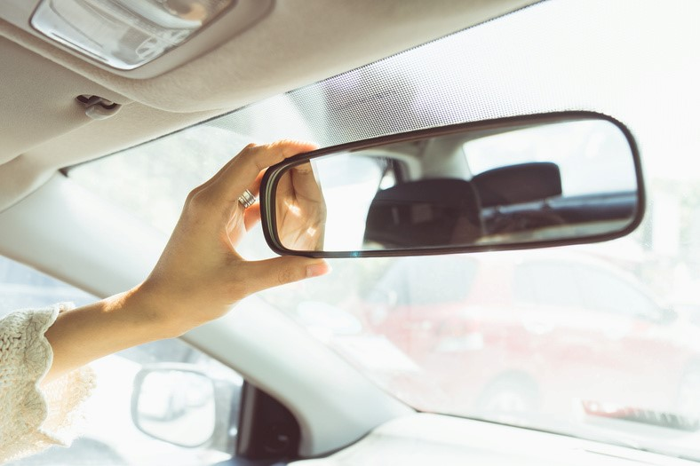
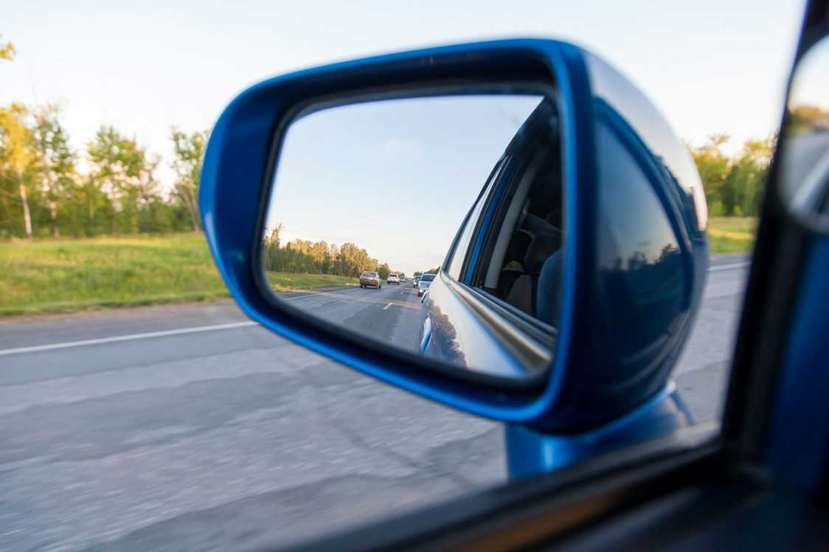

A blind spot is an area outside of your field of vision. Every vehicle has blind spots that can obstruct your view, keeping other drivers, parked cars, pedestrians, cyclists, and animals out of sight, and they’re even bigger for SUVs, hatchbacks, and trucks.
Blind spots are responsible for a lot of car accidents, but there are ways to avoid them!
Blind Spot Safety Tips
No driver should rely solely on their mirrors. Use them, but always check over your shoulder.
If a vehicle is within your field of vision and then suddenly you don’t see it, assume it’s in your blind spot.
Be aware of other drivers’ blind spots and try to stay out of them.

