The Importance of Water Safety Talk
Water is one of the most important substances on Earth. All plants, animals, and people need water to survive. Water serves very important purposes to our bodies and our bodily functions- some of which you may not even be aware of.
Interesting Facts Regarding Water’s Role in Our Bodies
- Water comprises more than 60% of our body weight.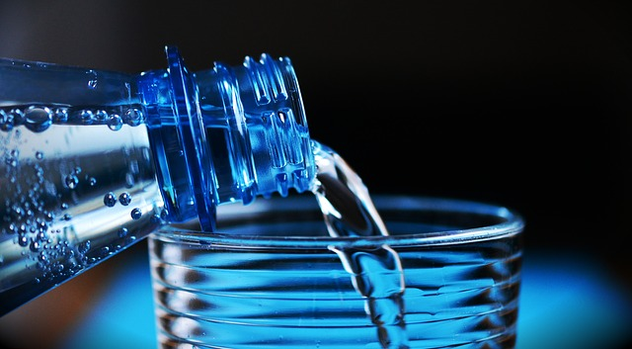
- Lack of water is the #1 trigger for daytime fatigue.
- A 2% drop in the water level of the body can spur problems with short-term memory.
- Water naturally cleanses the body of toxins.
- Water regulates the body’s cooling system.
- Water acts as a lubricant and cushion to our joints.
- Water is essential for a clear and hydrated skin.
Hydration Tips
- Drink plenty of water. It is recommended to drink at least ½ your body weight in oz of water a day, depending on what source you refer to. That is about three to four regular-sized water bottles a day. This amount is a minimum amount to shoot for; you may need even more water than that. Many people do not realize how little water they drink. Pay attention to how much you drink today and add to it if needed.
- Stay hydrated. Do not wait until you are thirsty to drink water to keep your body hydrated. By the time the body tells you that you are thirsty, dehydration is already occurring.
- Other beverages, such as soda or coffee, steal water from your body and make you even more dehydrated. Limit these types of drinks throughout the day.
- Your urine can serve as an indicator of whether you are hydrated or not. If your urine is clear or pale and you are using the restroom regularly, you are probably hydrated. If your urine is dark and you are visiting the restroom less frequently, you need to drink more water. While you should not solely rely on this indicator, it can be helpful in gauging whether or not you need to drink more water.
************************************************************************
Discussion point:
– How many people think they drink at least 3 to 4 water bottles worth of water a day?
Dehydration occurs when you don't have enough fluids in your body. Severe dehydration can cause serious problems. If you suspect you are (or someone else is) severely dehydrated, seek medical attention.
You are dehydrated when your body doesn't have enough water to keep it working properly. It can happen when your body loses too much fluid.
When your body has enough water to work properly, you are hydrated.
What are the signs and symptoms of dehydration?
If you have mild to moderate dehydration, you might:
- be thirsty
- have a dry mouth, lips and tongue
- be dizzy or light-headed, particularly when standing up
- have a headache
- have dark urine (wee) and not so much wee as normal
If you have severe dehydration, you might:
- be extremely thirsty
- have a very dry mouth
- be breathing fast
- have a fast heart rate and a low blood pressure
- have a fever
- have little or no urine (wee)
- be irritable, drowsy, or confused
If you experience any symptoms of dehydration, you should:
- move to a cool place
- loosen any tight clothing and remove unnecessary clothes
- drink small amounts of cool water, often
If your symptoms don’t improve seek medical advice.

What causes dehydration?
People can get dehydrated:
- after strenuous exercise, especially in hot weather
- after severe vomiting or diarrhoea
- with a fever
- after drinking too much alcohol
- while taking certain medicines such as diuretics
- as a complication of diabetes
- if they don’t drink enough water
Anyone may become dehydrated, but babies, young children, older adults, and people with long-term illnesses are at most risk.
Dehydration in older people
Older people can become easily dehydrated because of:
- poor kidney function
- chronic illness
- limited mobility
- certain medicines (particularly diuretics)
Dehydration in the elderly can cause problems such as:
- confusion
- constipation
- dizziness
- weakness
Elderly people need to keep up their fluid intake. They may become dehydrated before they feel thirsty. If you’re caring for an elderly person, you need to remind them to drink regularly.
*************************************************************************************************************************************************************************************************************************************************************************************************************************************************************************************************************************************************************************
Dehydration occurs when you use or lose more fluid than you take in, and your body doesn't have enough water and other fluids to carry out its normal functions. If you don't replace lost fluids, you will get dehydrated.
Anyone may become dehydrated, but the condition is especially dangerous for young children and older adults.
The most common cause of dehydration in young children is severe diarrhea and vomiting. Older adults naturally have a lower volume of water in their bodies, and may have conditions or take medications that increase the risk of dehydration.
This means that even minor illnesses, such as infections affecting the lungs or bladder, can result in dehydration in older adults.
Dehydration also can occur in any age group if you don't drink enough water during hot weather — especially if you are exercising vigorously.
You can usually reverse mild to moderate dehydration by drinking more fluids, but severe dehydration needs immediate medical treatment.

